CH 8 Pre-Test #3
Cycling of Matter & Energy Flow

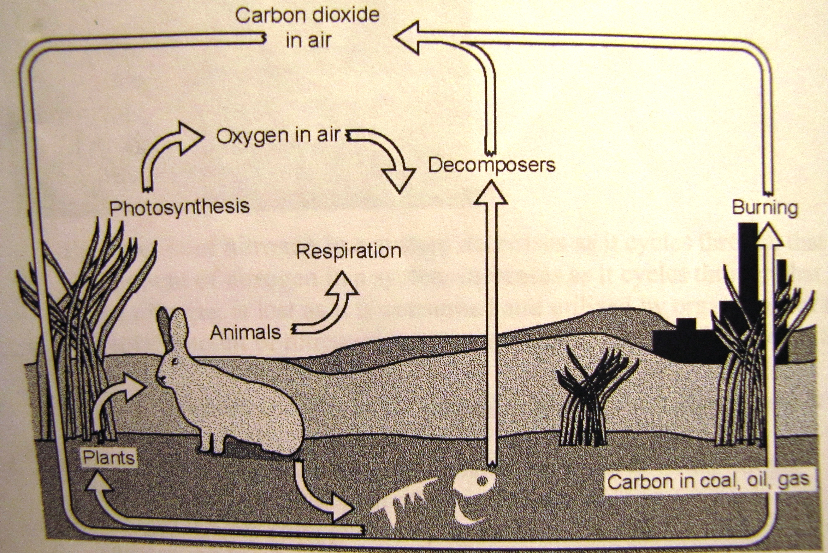

For #1 & 2 refer to the diagram above
- How does photosynthesis affect the carbon cycle? (READ CAREFULLY)
  - Photosynthesis adds CO₂ to the atmosphere, but does not affect O₂ levels
  - Photosynthesis adds O₂ to the atmosphere, but does not affect CO₂ levels
  - Photosynthesis adds O₂ to the atmosphere, while removing CO₂
  - Photosynthesis adds CO₂ to the atmosphere, while removing O₂

- Which of these does NOT return CO₂ to the atmosphere?
  - Burning fossil fuels
  - Photosynthesis
  - Decomposition
  - Animal respiration

- Which macromolecule is nitrogen an important part of?
  - Proteins c. Carbohydrates
  - Cellulose d. Lipids

- Nitrogen fixation is part of which cycle?
  - Carbon cycle c. Oxygen cycle
  - Nitrogen cycle d. Phosphorus cycle

- Parts of the environment that are living
  - Biotic c. Abiotic
  - Autotrophic d. Heterotrophic

- As nitrogen cycles through the atmosphere, soil, and living things…
  - The amount of nitrogen decreases as it cycles through the system
  - The amount of nitrogen increases as it cycles through that system
  - Some nitrogen is lost as it is consumed by organisms for metabolism
  - The total amount of nitrogen in a system does not change

- A carbon atom that is part of a plant’s stem
  - Could become part of an animal, but not part of the environment
  - May have been part of an ancient plant that was burned for fuel
  - Could become part of the soil, but not a gas in the atmosphere
  - May have been a nitrogen atom before it was turned into a carbon atom

- During cellular respiration, organisms return CO₂ to the atmosphere. This is a key part of which cycle?
  - Nitrogen cycle c. Carbon cycle
  - Water cycle d. Oxygen cycle

- Which statement is true?
  - Matter and energy cannot cycle between the biotic and abiotic parts of an ecosystem
  - Matter and energy can cycle between the biotic and abiotic parts of an ecosystem
  - Matter in living things stays in living things, it cannot become part of the environment
  - Energy in living things stays in living things, it cannot become part of the environment

- Fossil fuels
  - Are part of the nitrogen cycle and are made from melting minerals near the earth’s core
  - Are part of the carbon cycle and are made from melting minerals near the earth’s core
  - Are part of the nitrogen cycle and are made from decaying ancient organisms
  - Are part of the carbon cycle and are made from decaying ancient organisms

- Which statement about decomposers is false?
  - Fungi and bacteria are both decomposers
  - They are part of the carbon cycle, but not the nitrogen cycle
  - They are part of the carbon & nitrogen cycles
  - They are part of the nitrogen cycle, but not the carbon cycle

- The energy in an ecosystem
  - Cannot change forms
  - Can never move into or out of the ecosystem
  - Could change forms and may move out of the ecosystem
  - Is only found in living things, not non-living things (ex: rocks)

- As plants and animals break down the bonds in food…
  - Some of the energy held in the bonds moves into the environment
  - All of the energy in the bonds gets used by the organism
  - All of the energy held in the bonds moves into the environment
  - Energy from the bonds becomes matter in the plants, animals, and environment

